Guide
Code it on production Caltech account, since they are not live.
Look for custom item fields:

Create new item and apply
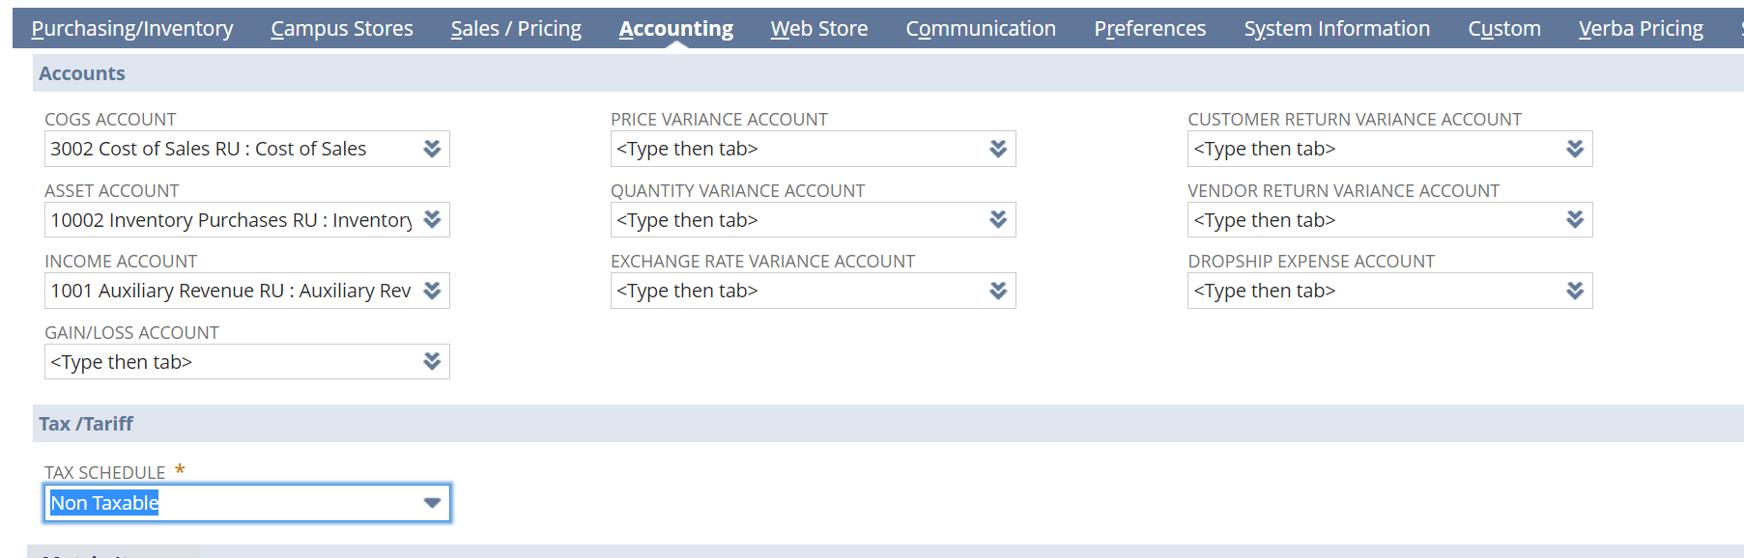
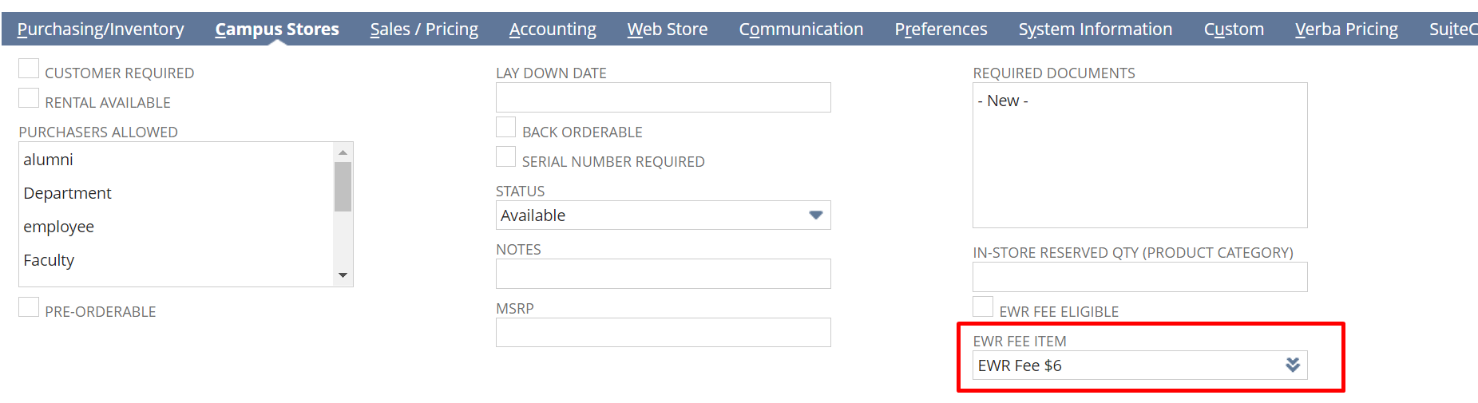

Then: record types and look for ra-settings and press list.
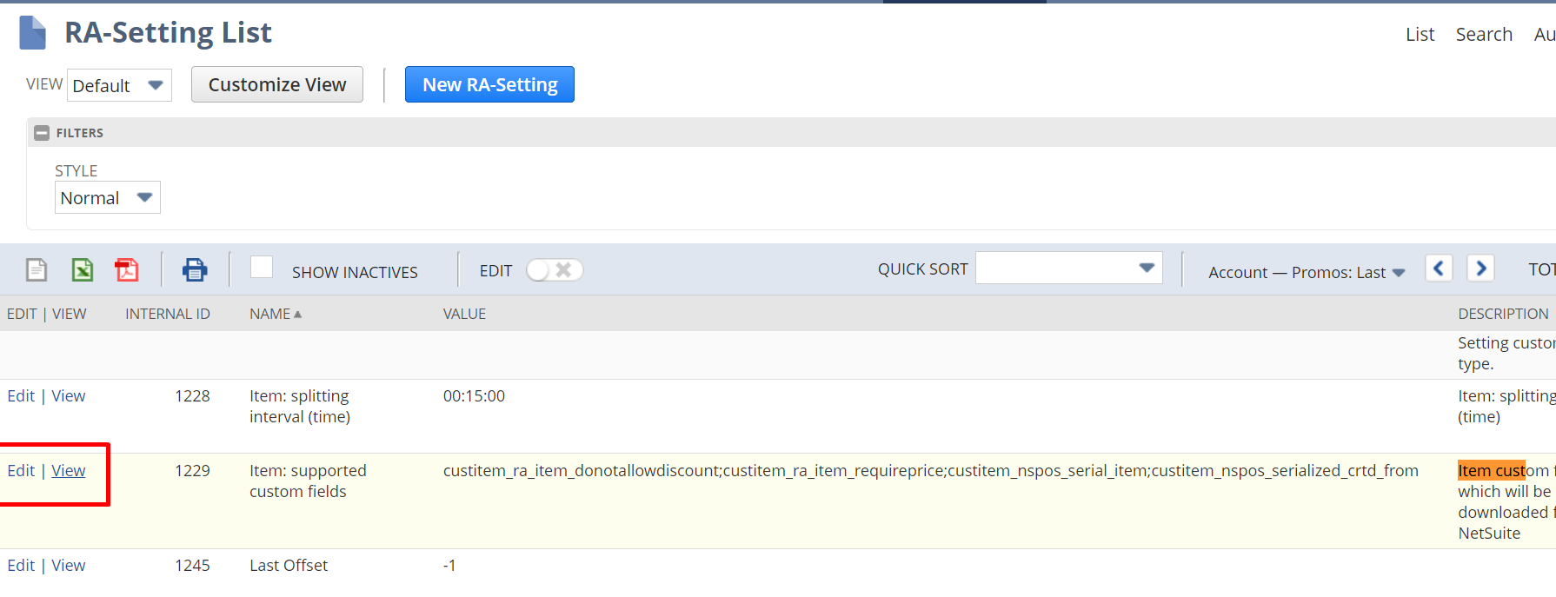
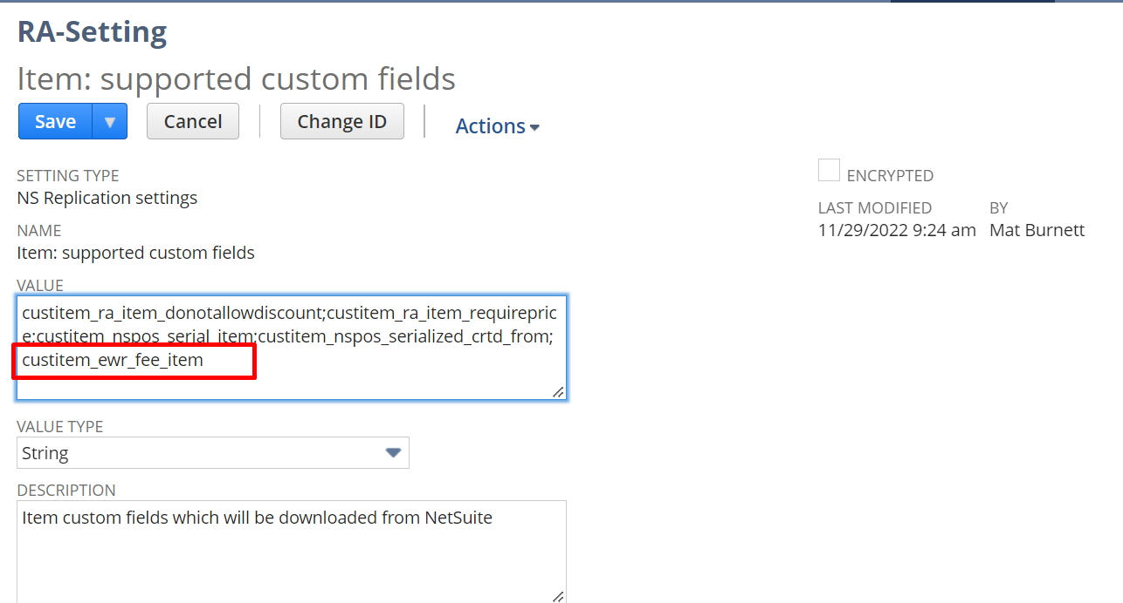
We did not add this custom field to the RA-Setting record before we modified the item, so we need to update the item. And then to trigger update on the item, we need to do this:
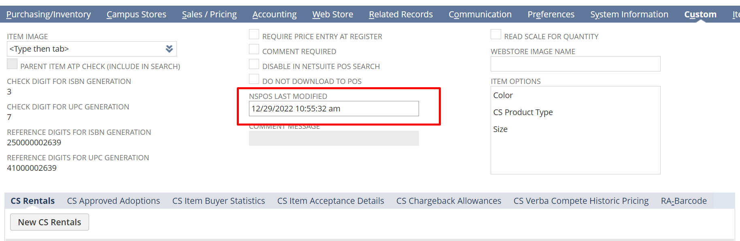
Change the date, to twelve, and then save and you will see it will go to 11.

Upload script to:
This executes whenever you add a line item. That’s why it says events added line item.
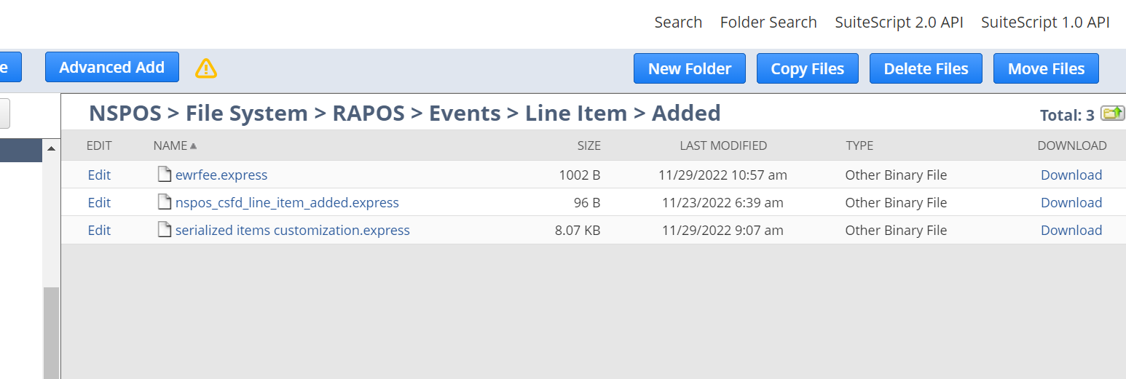

Create nspos operator id
Add operator id to your employee record
Then create ra-workstation

